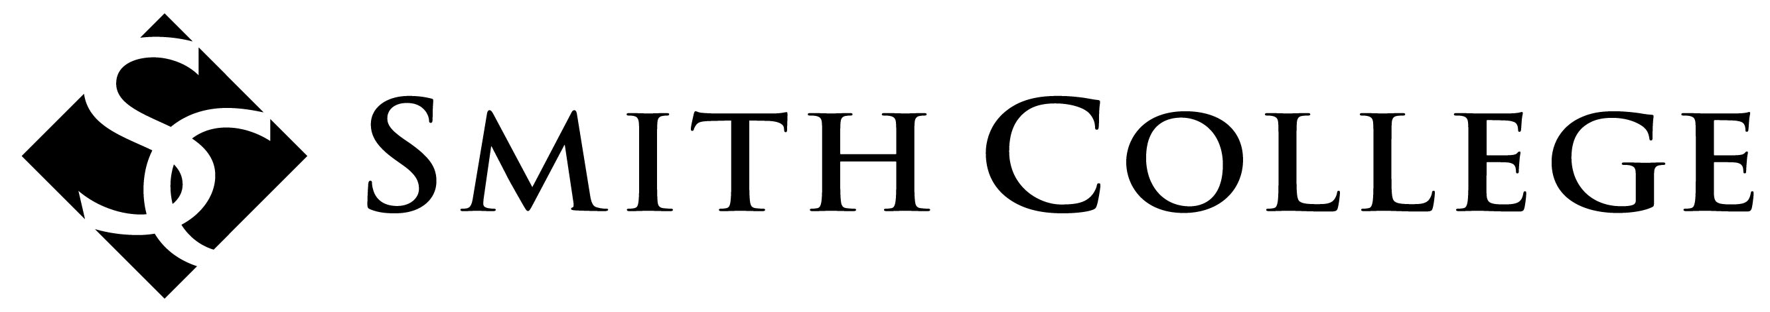
Museums
Concentration

Practical Experience Pre-Approval Form
In order to be assured that your practical experience will meet the requirements of the Museums Concentration, please complete and discuss this form with your Concentration adviser prior to beginning the internship or other work experience. Submit the completed form to Russel Altamirano (museduc@smith.edu, Campus address: Museum of Art, Tryon Hall).

Name: |  | Graduation Year:
Concentration Advisor:
Site for Proposed Internship, Volunteer, or Work Experience | Name of Site:  Supervisor  Name and Title:  Phone:  Email Address:
On a separate sheet of paper describe the proposed internship or work experience, addressing these questions: | - Describe your goals for your work in this practical experience. What tasks do you expect to do? How do you think this work will complement your academic course work?  - What skills do you hope to develop? How will this experience deepen your knowledge about museums? If this is a second practical experience, how will it build upon or diversify your skills?  - Picture yourself at the conclusion of this practical experience. What would success look like for you?
Begin and end dates
Anticipated total work hours

To be completed by Concentration Adviser:

Practical experience discussed with student

Approved (proposed experience meets requirements)

Adviser signature: Date:

